

Karlene Joyce Baes

Rouen Inawasan

Jay Czhelle Soberano

RICE PROCUREMENT AND DISTRIBUTION

MANAGEMENT SYSTEM

An Undergraduate Thesis

Presented to the Faculty of the

College of Information and Communications Technology

West Visayas State University

Luna St., La Paz, Iloilo City

In Partial Fulfillment

of the Requirements for the Degree

Bachelor of Science in Information System

Karlene Joyce Baes

Rouen Inawasan

Jay Czhelle Soberano

June 2022

**DISCLAIMER**

This software project and its corresponding documentation titled “Rice Procurement and Distribution Management System” is submitted to the College of Information and Communications Technology, West Visayas State University, in partial fulfillment of the requirements for the degree, Bachelor of Science in Information System. It is the product of our own work, except where indicated text. We hereby grant the College of Information and Communications Technology permission to freely use, publish in local or international journal/conferences, reproduce, or distribute publicly the paper and electronic copies of this software project and its corresponding documentation in whole or in part, provided that we are acknowledged.

|  |  |
| --- | --- |
| Karlene Joyce Baes | Rouen Inawasan |
| Jay Czhelle Soberano | |

June 2022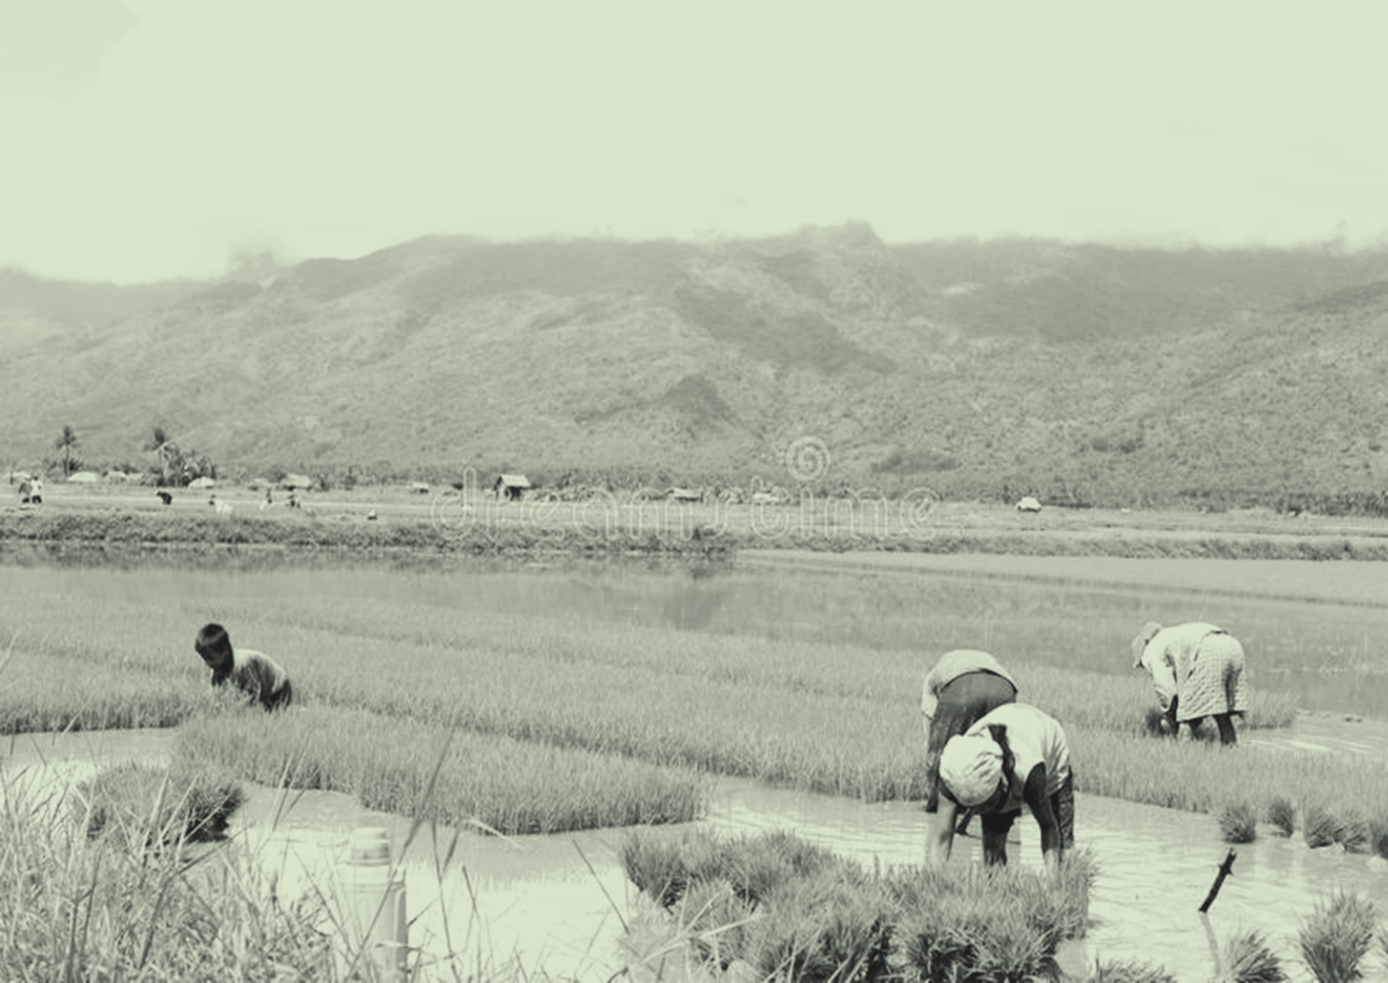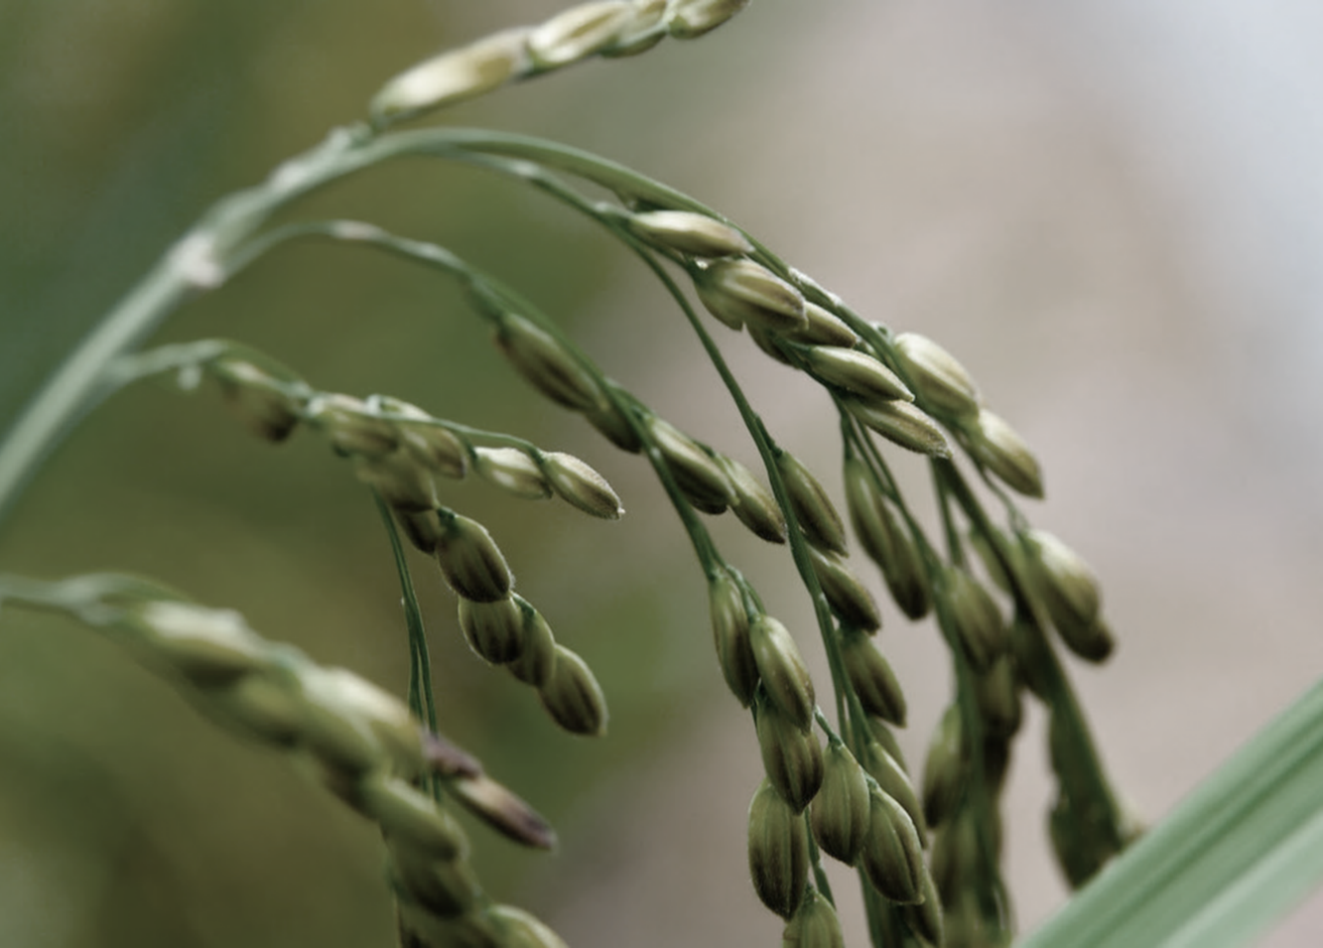

West Visayas State University

COLLEGE OF INFORMATION AND COMMUNICATIONS TECHNOLOGY

La Paz, Iloilo City

USER’S MANUAL

**Rice Procurement and Distribution Management System**

**Rouen Inawasan**

**Karlene Joyce Baes**

**Jay Czhelle Soberano**

West Visayas State University

COLLEGE OF INFORMATION AND COMMUNICATIONS TECHNOLOGY

La Paz, Iloilo City

USER’S MANUAL

**Rice Procurement and Distribution Management System**

**Rouen Inawasan**

**Karlene Joyce Baes**

**Jay Czhelle Soberano**

|  |  |
| --- | --- |
| Title | Page |
|  |  |
| Title Page | 1 |
| Disclaimer Page | 3 |
| Table of Contents | 4 |
| Guide for Deploying and Using the System's Main Functions | 5 |
| Getting Started | 5 |
| Introduction | 5 |
| System Requirements | 5 |
| Installation | 5 |
| Usage | 6 |
| Deploying the system to the localhost server | 6 |
| Using the system per main features | 11 |
| FAQ (Frequently Asked Questions) | 26 |
| Contact Details of the Development Team | 28 |
|  |  |
|  |  |

**GUIDE FOR DEPLOYING AND USING THE SYSTEM’S MAIN FUNCTIONS**

**Getting Started**

*Introduction*

Rice Procurement and Distribution Management System is a web-based application system that is accessed via HTTP and runs in a web browser. This can help the farmers, traders and NFA when it comes to effective and efficient buy and sell transactions. This system has a different function and features one of these: a marketplace platform that connects the farmers, traders and NFA for selling and buying produce. This also gives the farmers the privilege to choose among the traders who bid for their produce based on the highest bidding or nearest location to them. This system also has a distribution scheduling model for NFA user to allocate and distribute the rice produce. This system also has an inventory management model to track the stocks levels in the warehouse. This document provides a software manual for the user on how to use the system and what software is needed to run the system.

*System Requirements*

In the hardware necessities, the researcher tested the system on a laptop with the processor of intel core i3-10056GI, 4GB DDR, 128GB SSD in a windows 10 Home.

*Installation*

The needed software to run the system is via web browsers such as Google Chrome and Microsoft Edge and the NodeJS to run the system on various platforms. Visual Studio for the code and web browser for the users.

**Using the System**

*Deploying the system to the localhost server*

1. To run the system to the localhost, Open the file of vscode of the system.

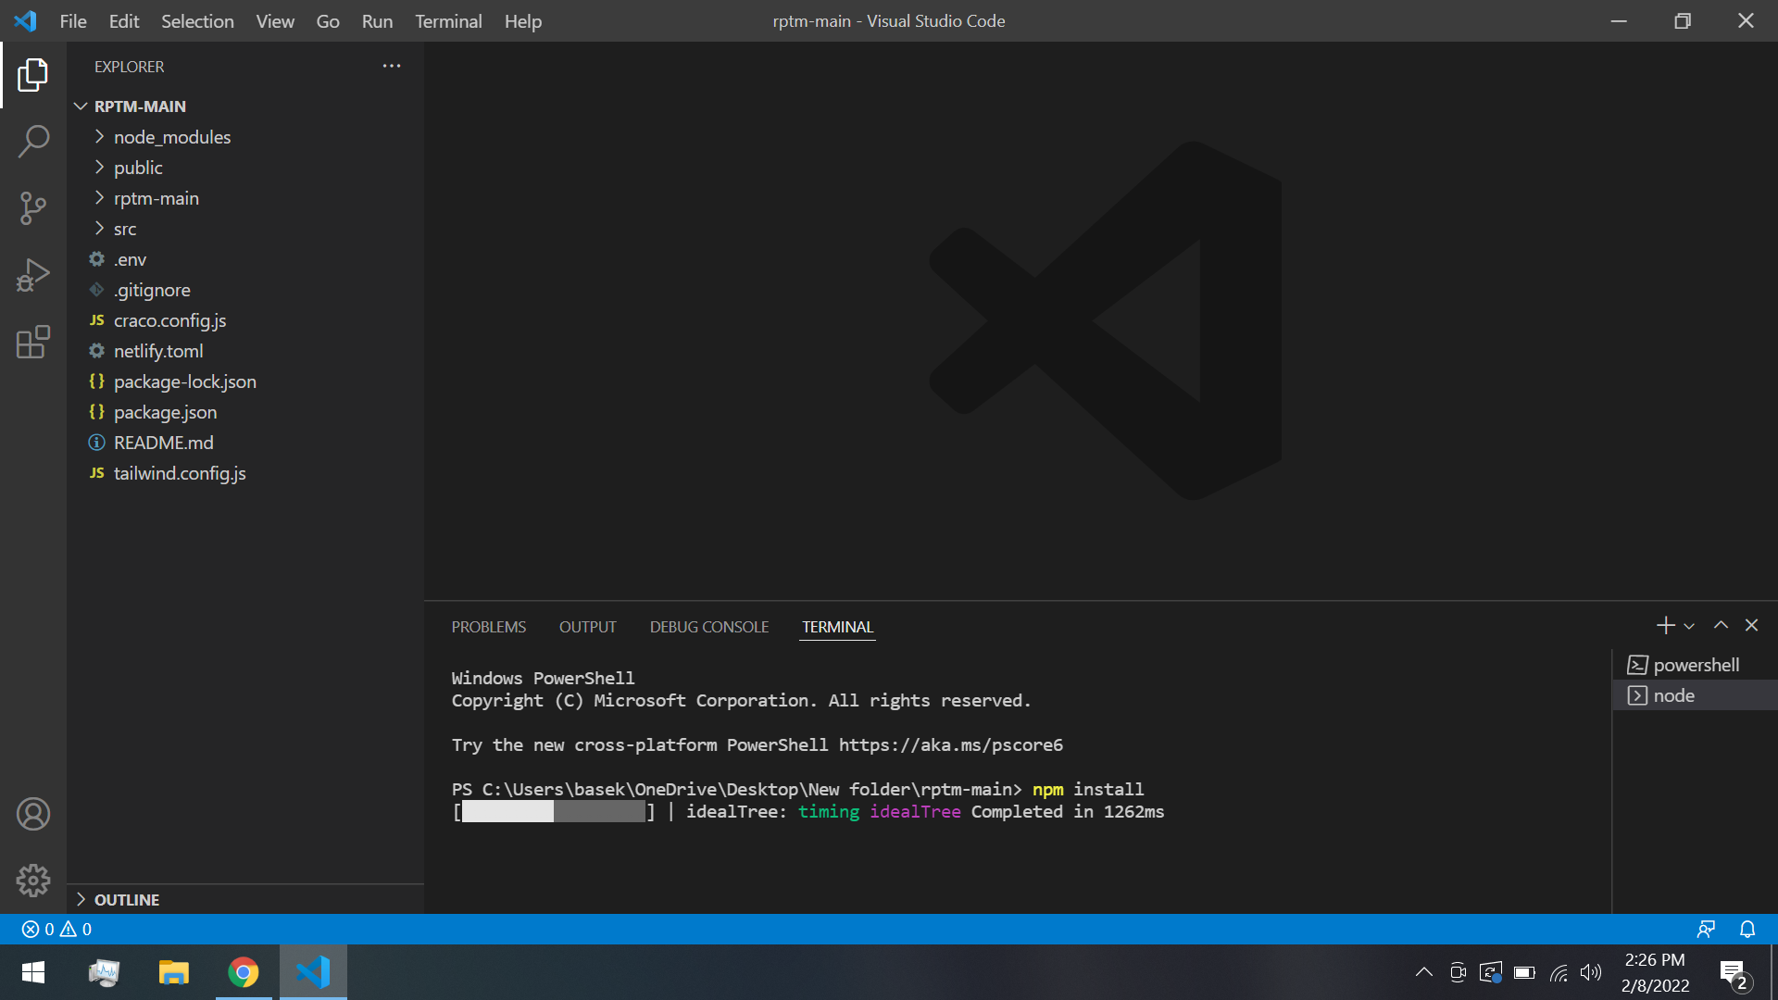

1. Download the **Nodejs** (https://nodejs.org/en/download/). Click the windows Installer if you’re using windows and macOS Installer is Mac then it will automatically download.

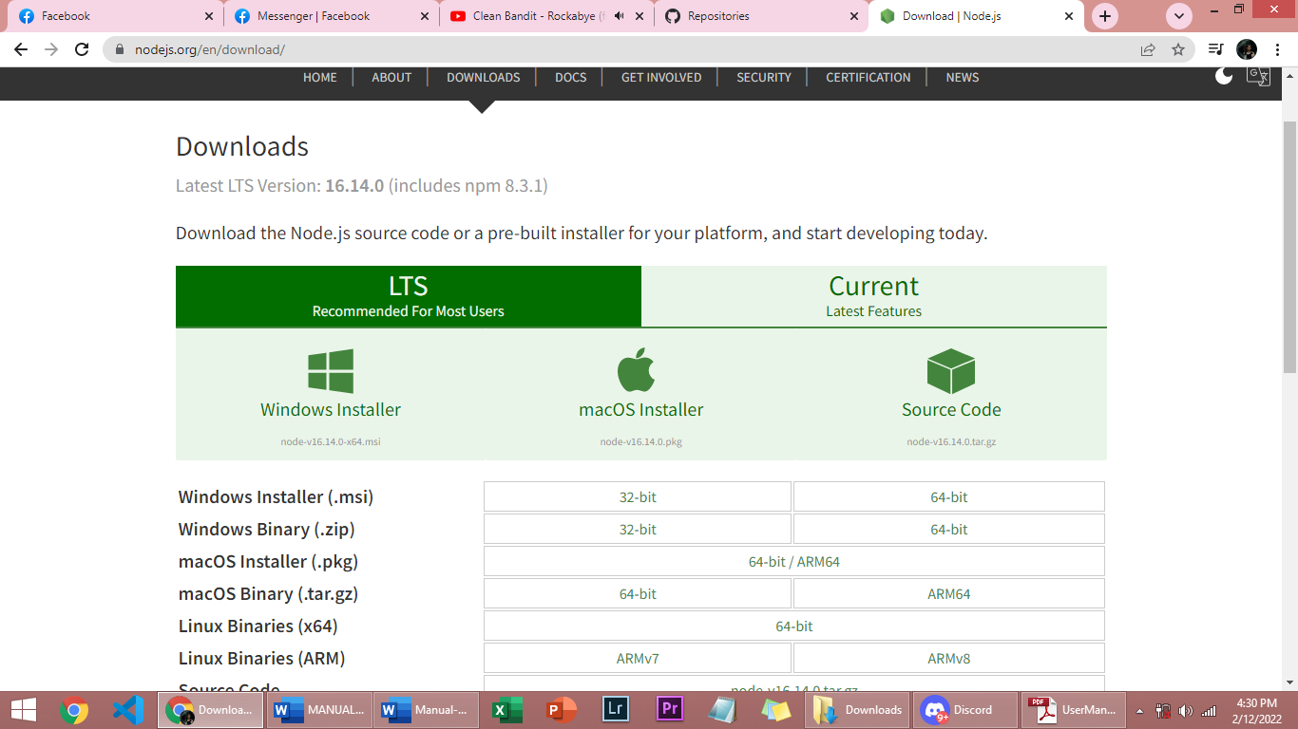

1. Open the downloaded file of nodejs then setup.

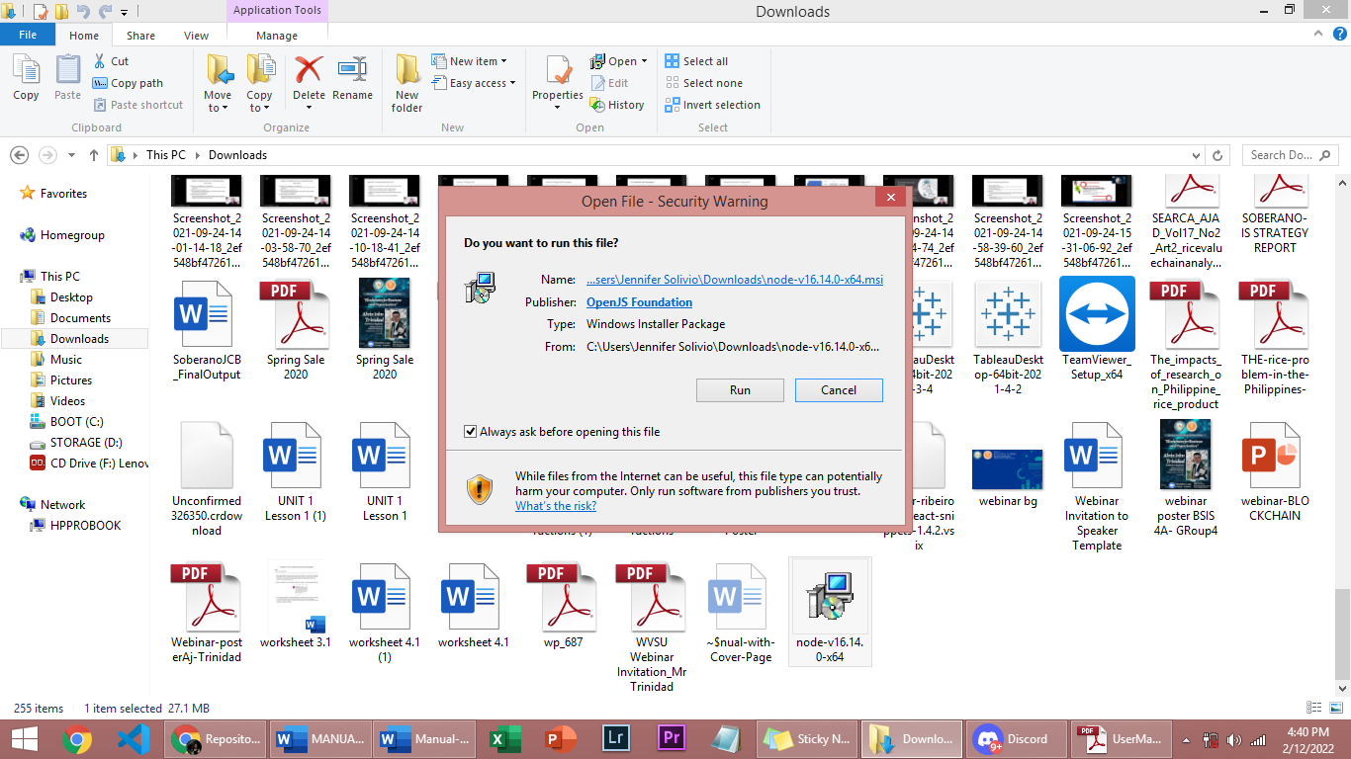

click **run,**

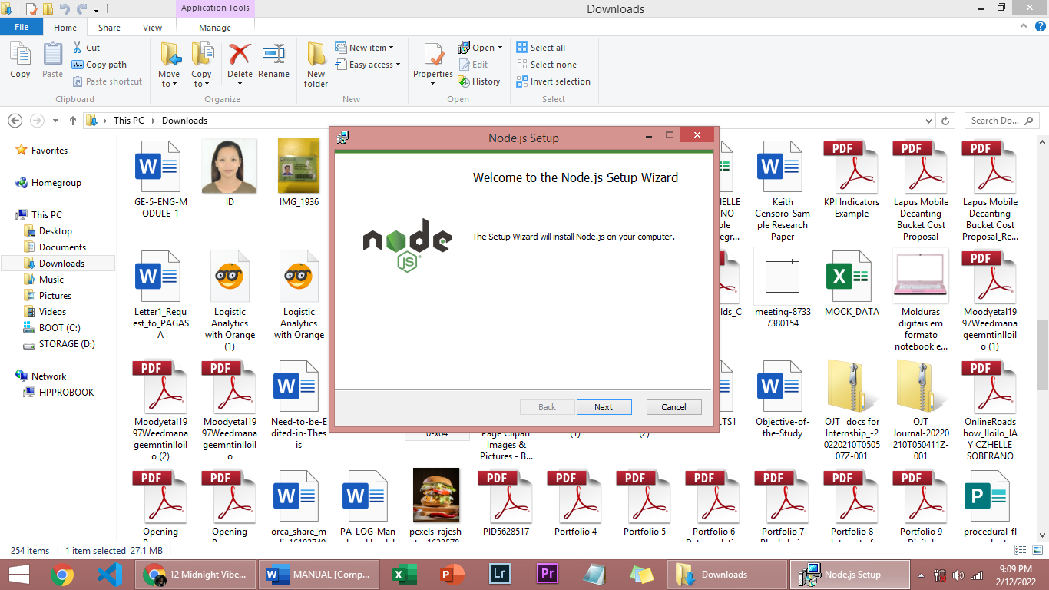

Click **I Agree,** then **Next**

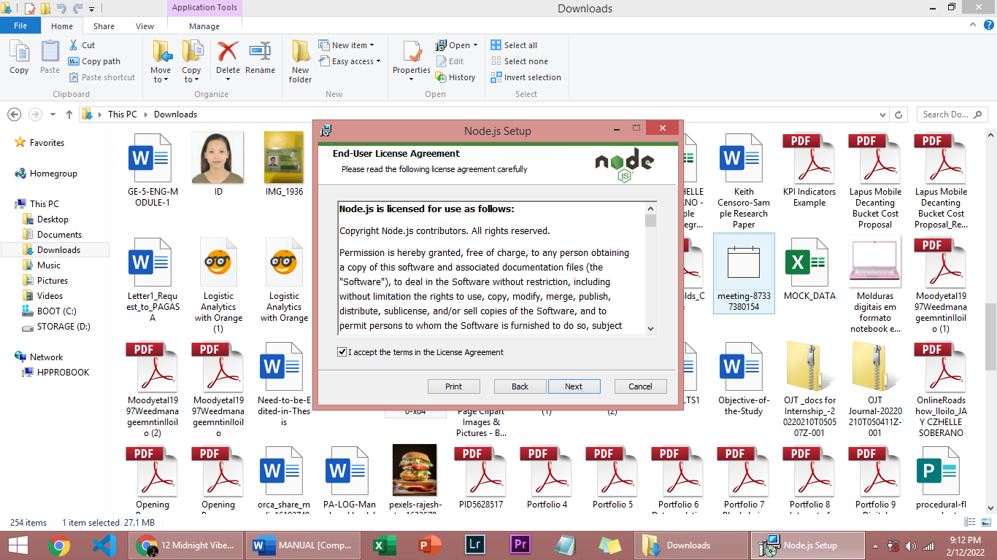

then, look for a location you want to install the Nodejs, then click, **Next**

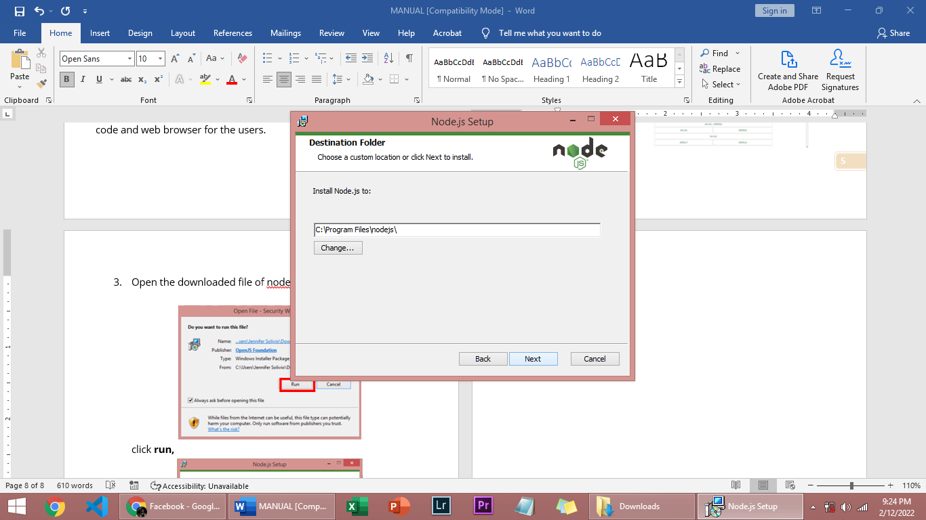

click **Next,**

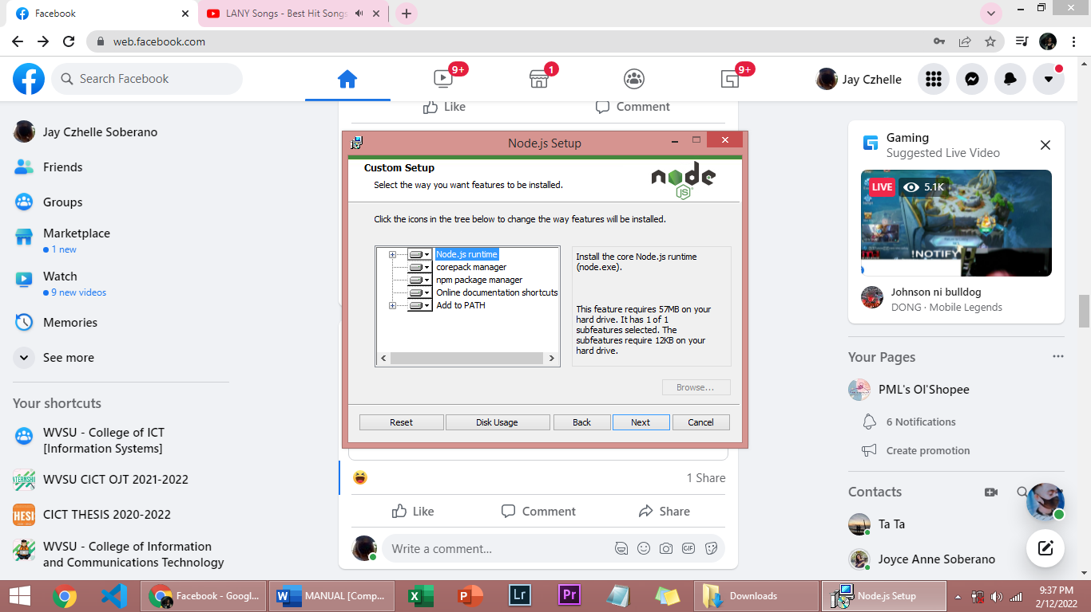

Click **Next,**

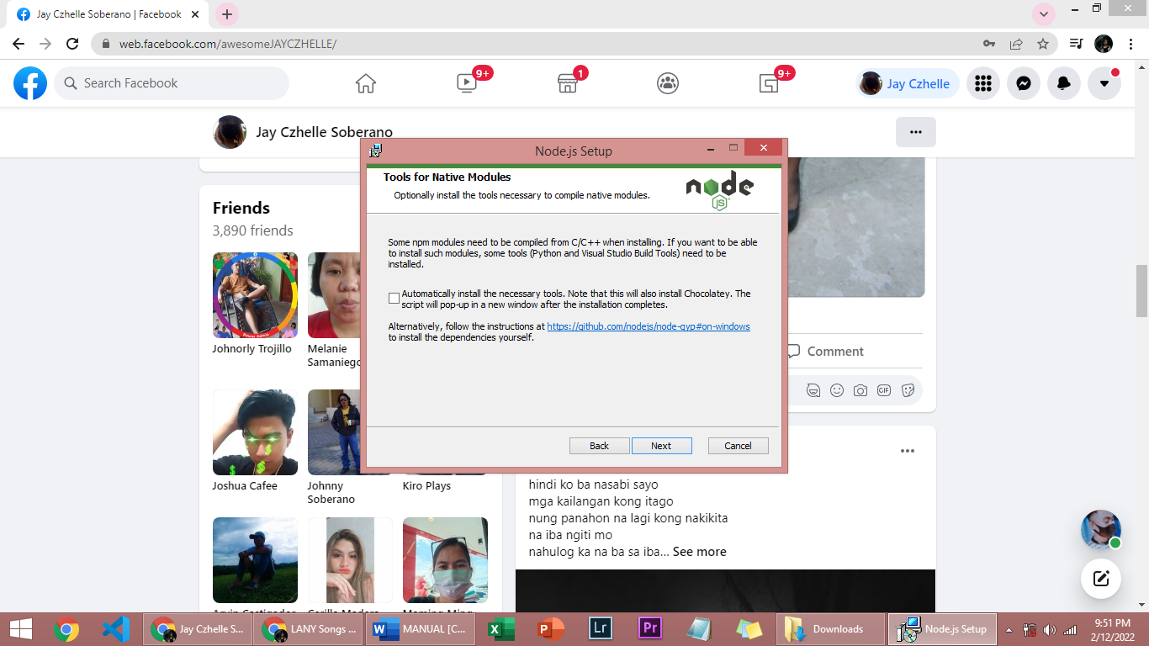

then, Click **Install.** Then **Finish.**

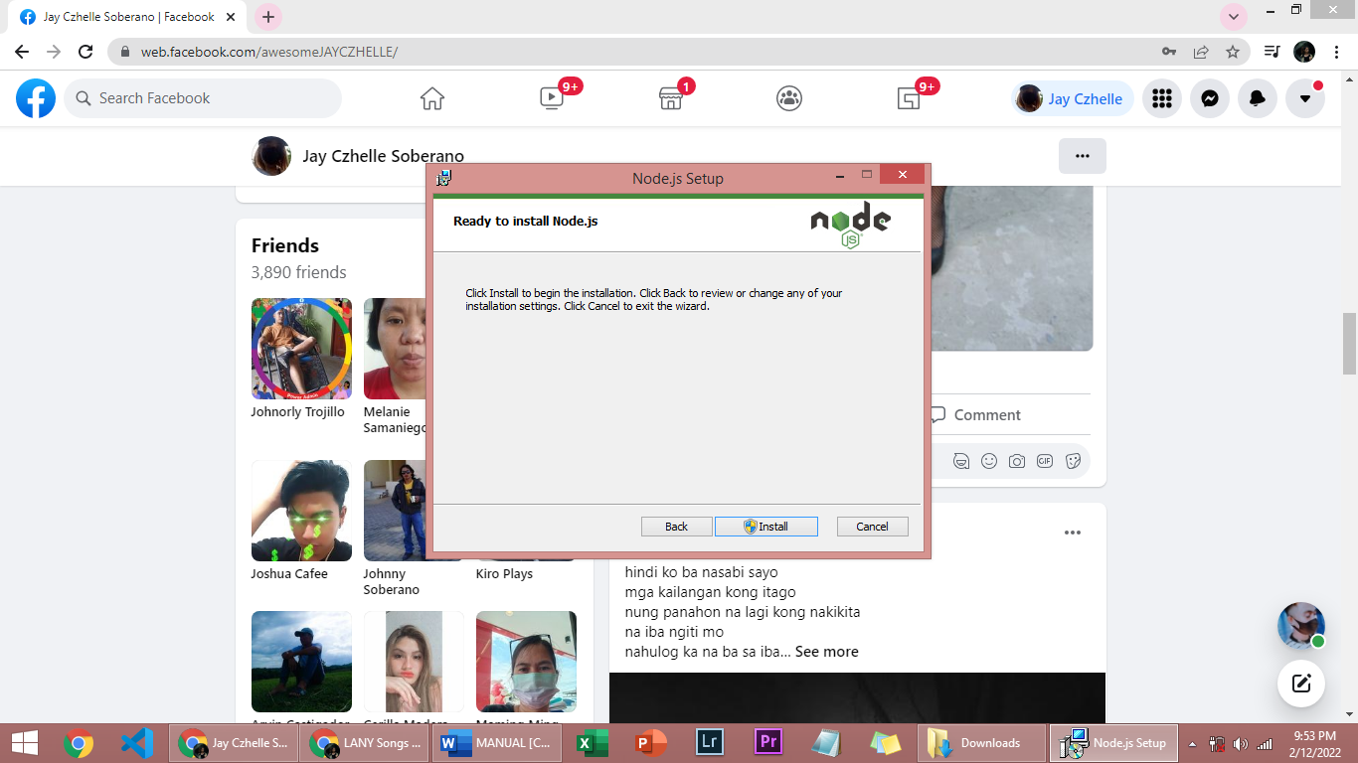

1. Back to the VSCode then click **Terminal,** then, **New Terminal.**

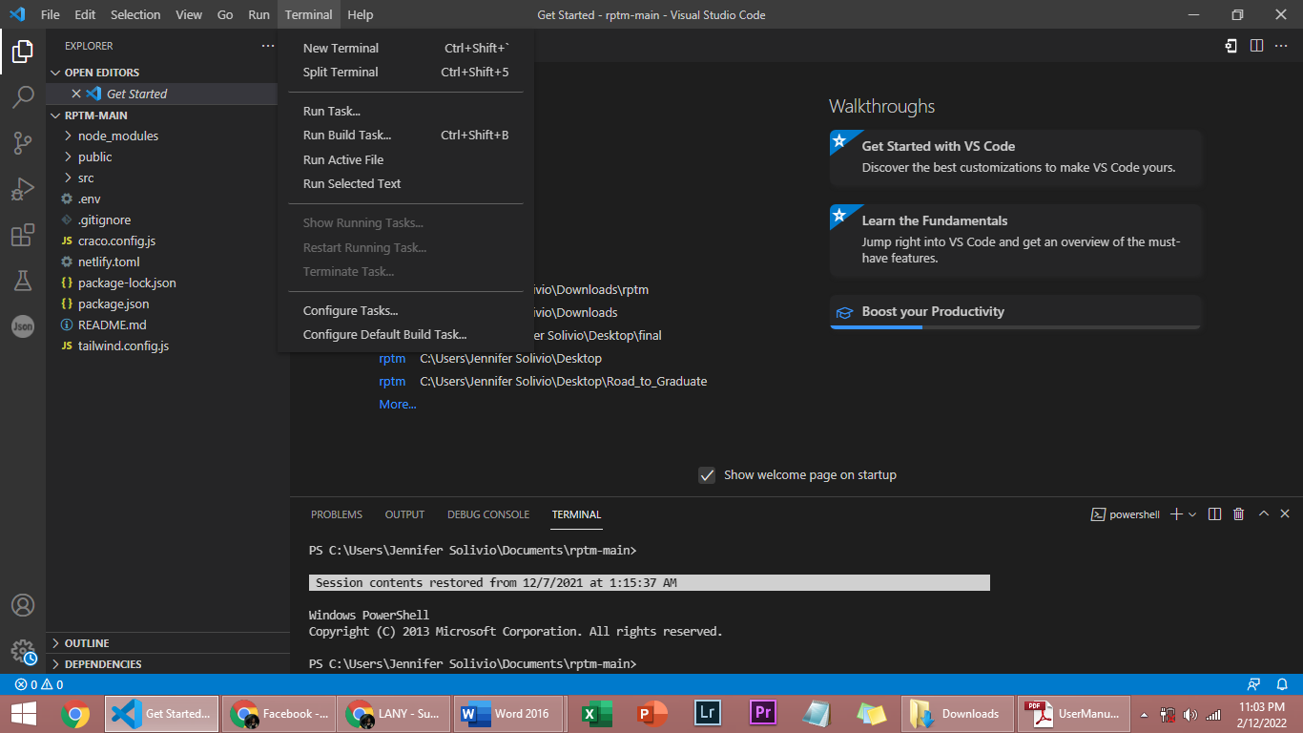

1. In the terminal, Input **NPM Install** to install the modules that are listed in package .json and their dependencies. then, **Enter.**

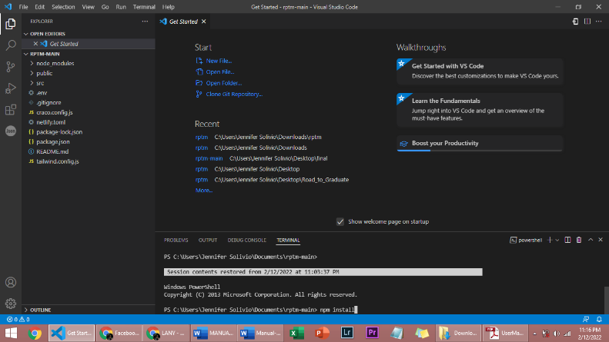

1. After the installation, Input **NPM START** to execute the defined file. then after that **Enter.**

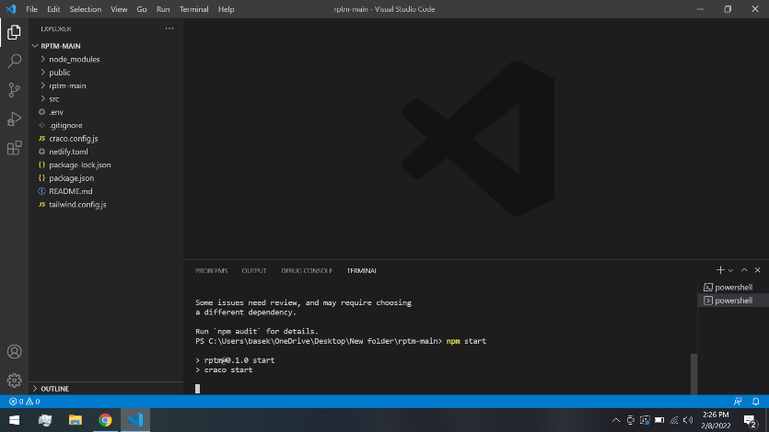

Then, the system will automatically open in the default web browser.

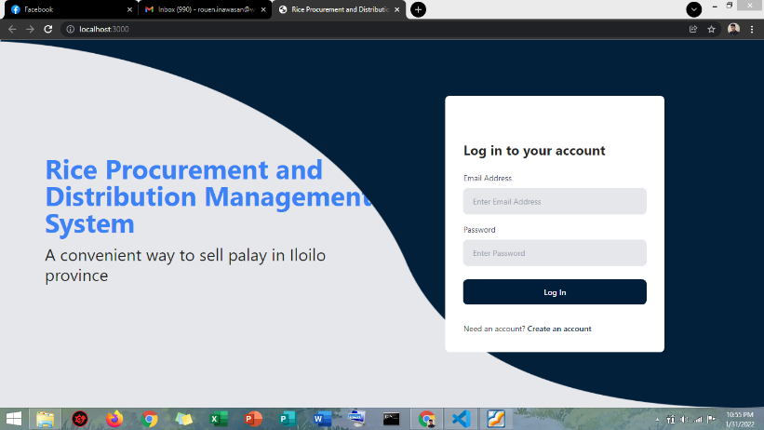

*Using the system per main features.*

**Farmer Side**

1. In the **farmer side**, the default page/ landing is the **marketplace**. where you can view different palay/rice that are sold by the different farmers. To bid, just click the **Price**. You can filter or sort the product by clicking the **Filter Category**

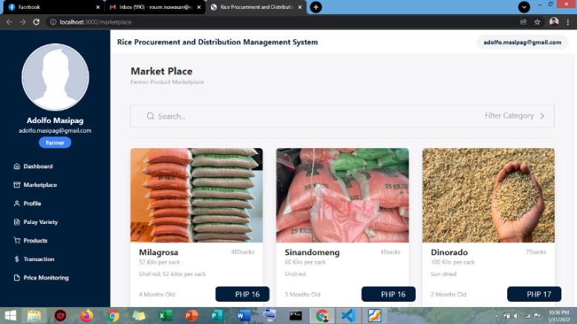

1. **Dashboard**, what they can view here are the **Total palay variety** they have, **Total product** they sell pr posted in marketplace, **Total Bidding Transaction** who bid their product and **Total Transaction History** who have successful transaction.

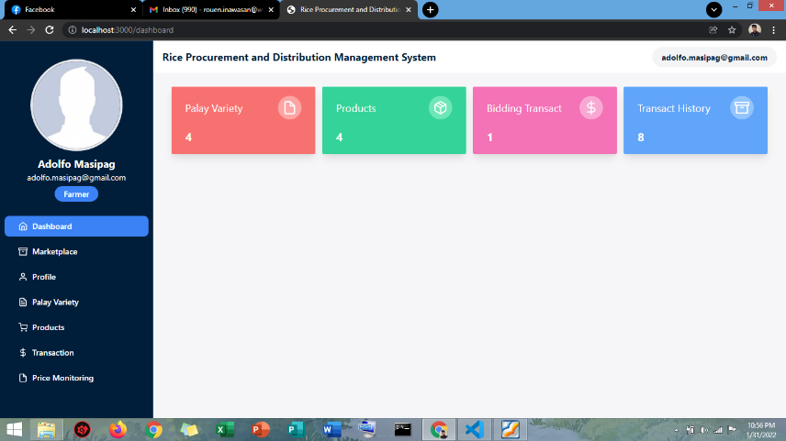

1. **Profile,** this page is a user’s personal information, whereas they can update, edit, and delete. In updating/ editing, click **Edit**, after you finish editing or update your information click **Save.**

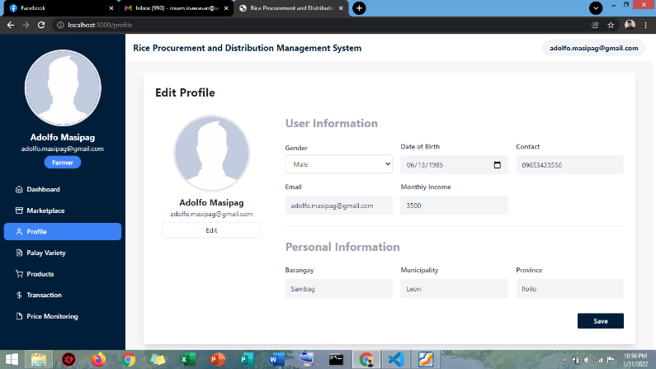

1. In **Palay Variety,** what you can view are the different palay varieties, whereas they can also **Add, Edit** and **Delete** variety.

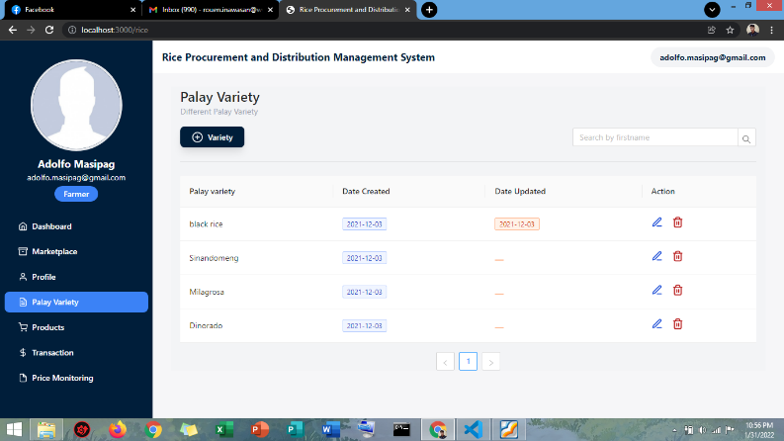

Click **Variety** to add then, the variety box will pop up, input your variety then click **Save** or **Cancel.**

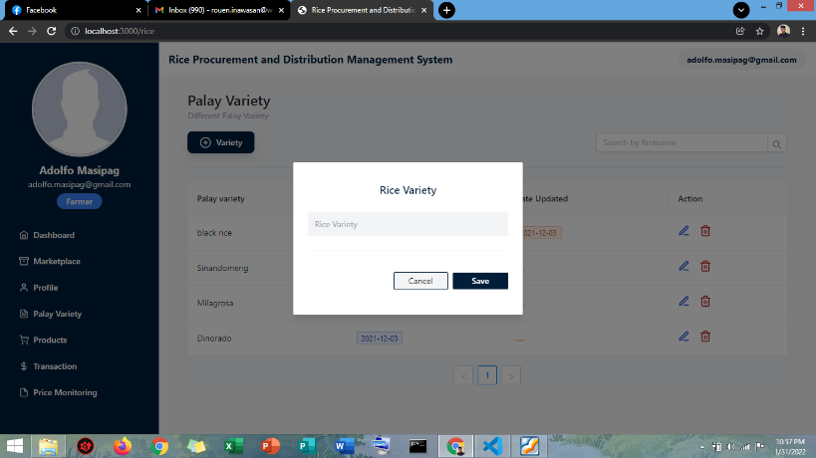

1. In the **Product page**, what they can view are the products that are posted in marketplace, in that page, the farmer user can edit and delete their product. These are the following steps:

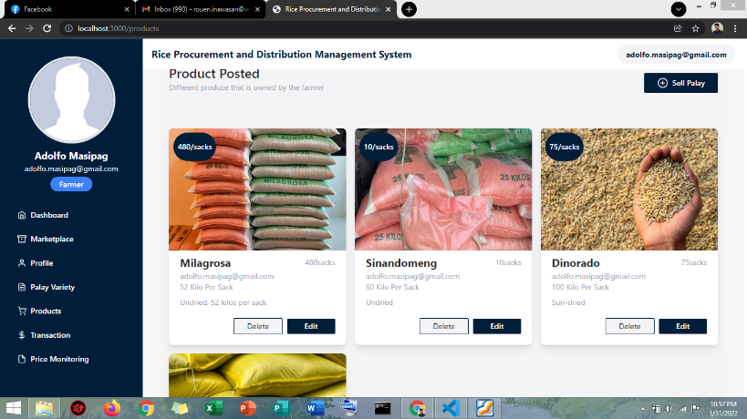

1. Click **Sell Palay,** then this page will pop up. Enter/ Select **palay variety**, then the **Owners email** is default, then, enter **Date Harvested**, then **Number of sacks**, **Kilo per sacks**, then, **Bidding Price** and **Description** then Upload a picture of Product by Drag and Drop or Select from the folder. After filling out, Click **Save.**

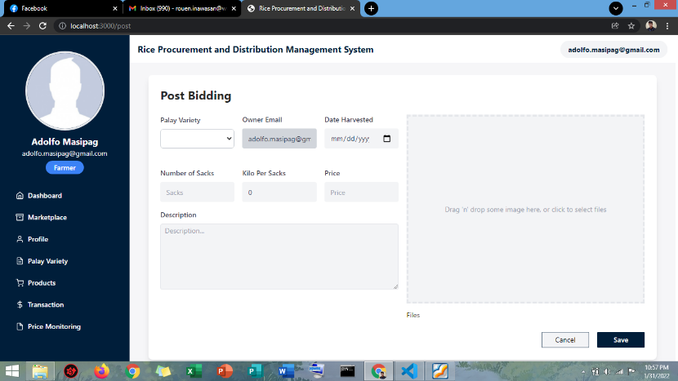

1. Click, **delete** if want to delete the product.
2. Click, **edit** if want to edit the product.

**Note:** All products that are posted on the product page can automatically be viewed or seen in the marketplace. If someone bids on the product, the number of palay that are bid is automatically deducted in the total number of sacks on the product page.

1. In **Transaction,** what they can view is the **bidding history** and the **transaction history**. The following are the usage:

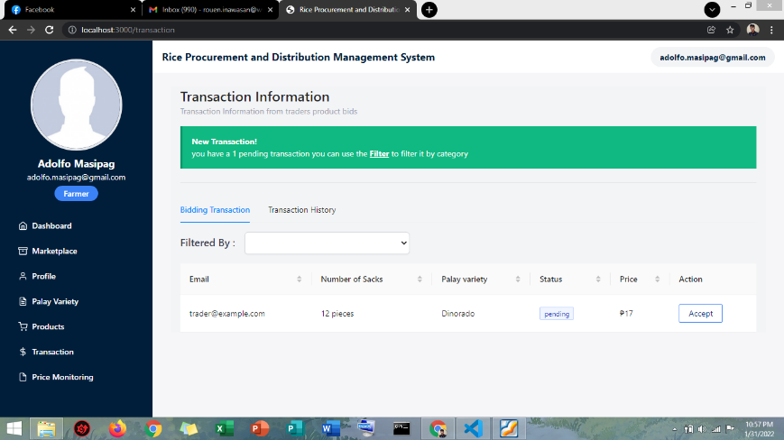

In **Bidding History**, these are where you can view the traders/ NFA bidding, you can choose here you desire buyers by clicking the **Accept** button. In **transaction History**, you can view the successful transaction here, you can filter or sort transaction by clicking **Filtered by.**

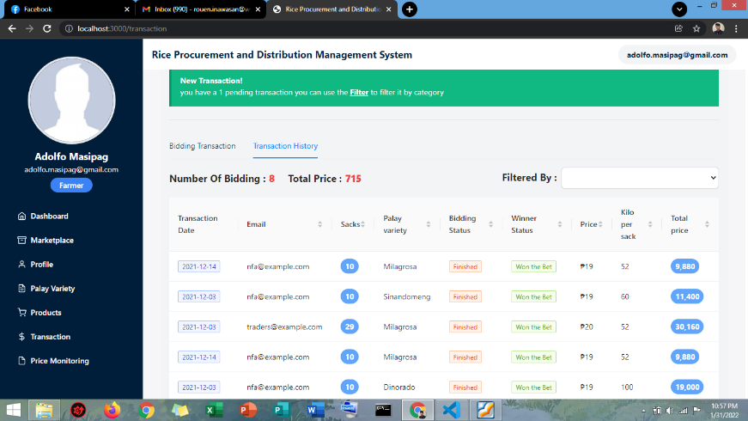

1. In **Price Monitoring,** what they can view here is the minimum and maximum price of transaction per variety. The usage of these pages is to determine the average price of product per variety in successful transaction.

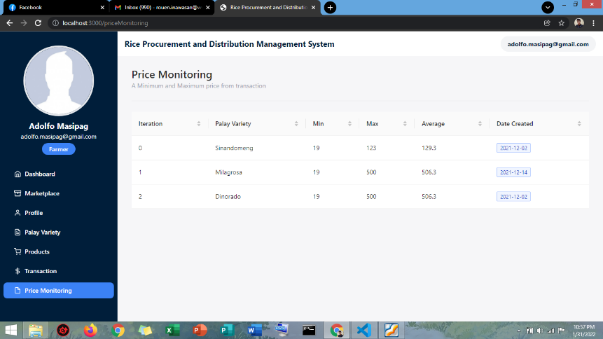

**Traders Side**

1. **Dashboard**, the usage of these dashboards in traders is to visualize the **total number of Won the bet**, **total number of lose the be**t and **total transaction** they have.

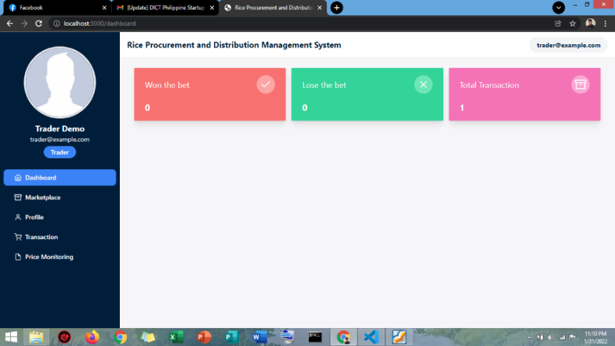

1. **Marketplace**, the usage of marketplace is where you can view and see the product of all farmers where you can select palay to bid.

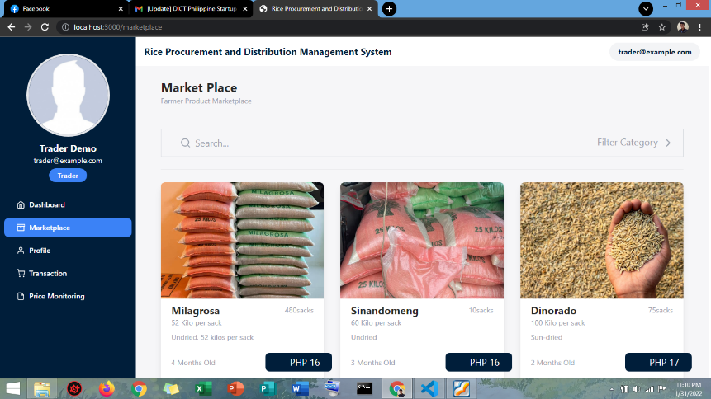

To bid palay, click the **Price,** then **email of the farmer**, in this case the email is already default, then **number of sacks** and **bidding price** then click **Place you bid.**

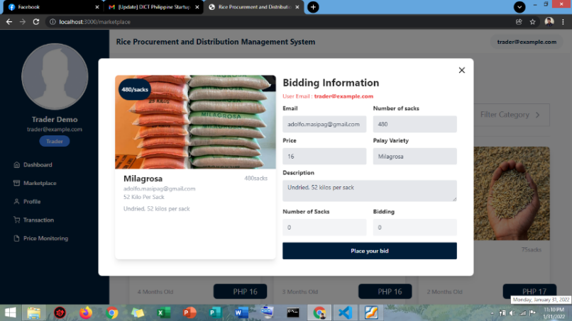

1. Profile, these are the user’s profile where they can update, edit, and delete information. Click **edit,** then after **Save.**

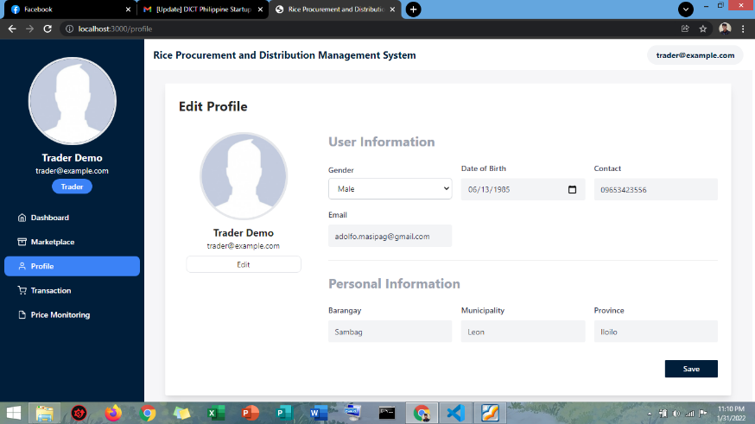

1. In **Transaction**, all products that you bid on in the marketplace can be seen or viewed here in a transaction whether it was accepted or still pending. You can filter transaction by clicking **Filter by**.

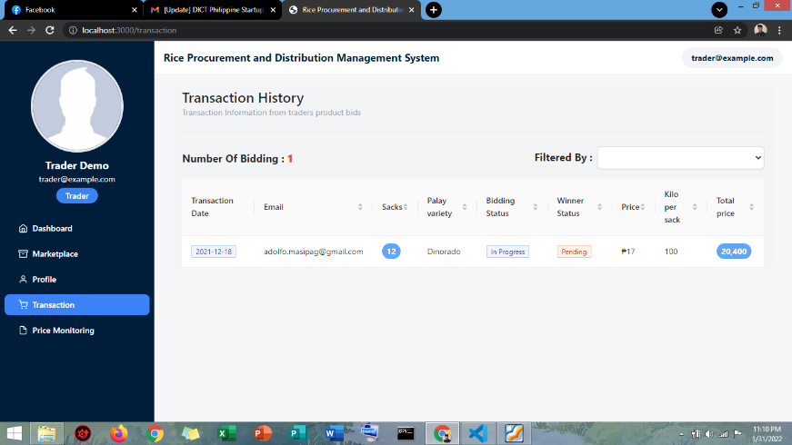

1. In **Price Monitoring,** what they can view here is the minimum and maximum price of transaction per variety. The usage of these pages is to determine the average price product per variety in successful transaction.

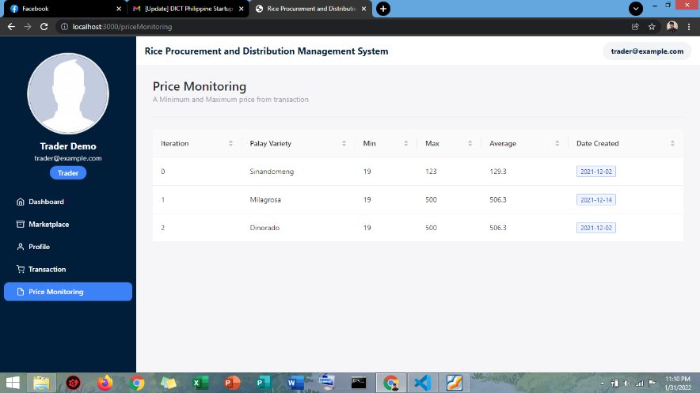

**NFA Side**

1. **Marketplace**, every time they sign in, they will be redirected to **marketplace**, where they can select farmers product.

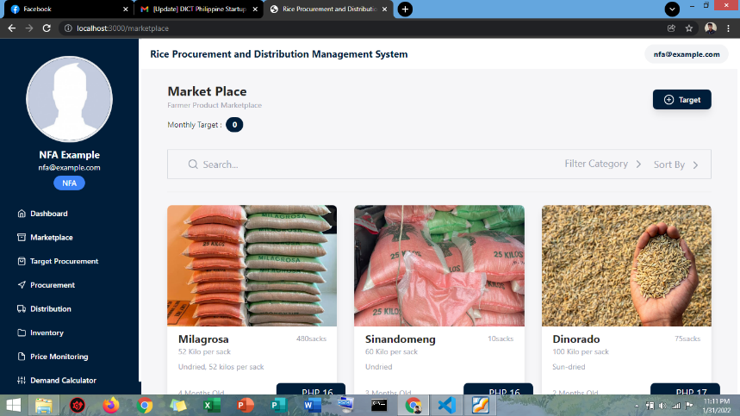

In **NFA**, they have a monthly target that needs to be procured. To add **monthly target**, click **Target,** then, the **target procurement** box will pop up, then **input the number** that need to procure then click **save** or **cancel.**

***Note:*** *The default bidding price of NFA 19 php.*

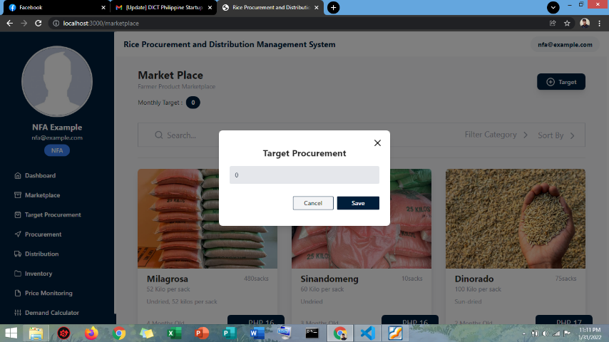

1. **Dashboard**, what they can view here are the **total procurement**, **distribution**, **total inventory,** and **total rice milled**. The usage of this page is to visualize the data that has been procured, distribute and inventory to monitor the buffer stocks.

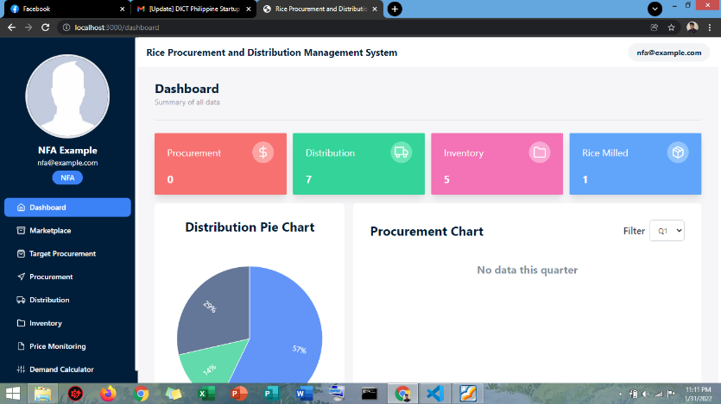

1. **Target Procurement**, the usage of this page is to identify and differentiate monthly targets they have in a year.

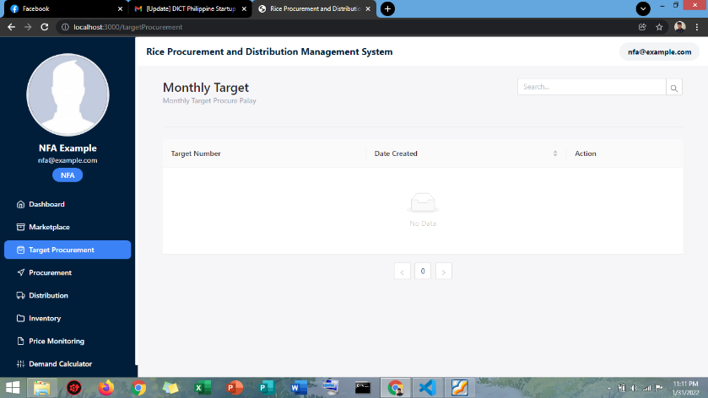

1. **Procurement**, these are procurement data of NFA. What you can view here is the **procured palay** from the farmer. The usage of this page is to easily **record and generate reports** of the procurement transaction of NFA. This record is automatically added to the number of inventory and visualized in the dashboard.

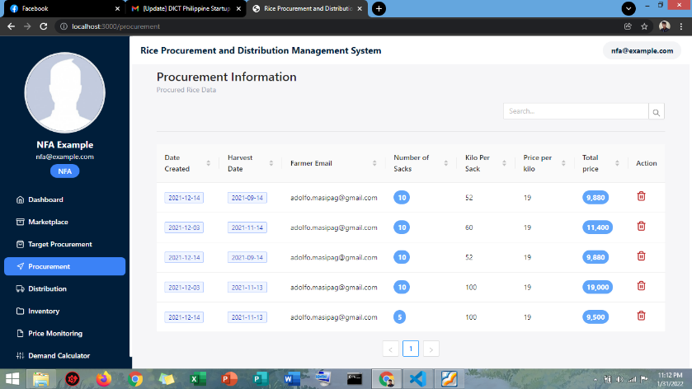

1. **Distribution**, these are the distribution data of NFA. There are 3 categories of distribution: the **Police supply**, **relief operation** and **market**. The usage of this page is to easily **identify the distribution**. The data in distribution are visualized in dashboard to easily analyze the data.

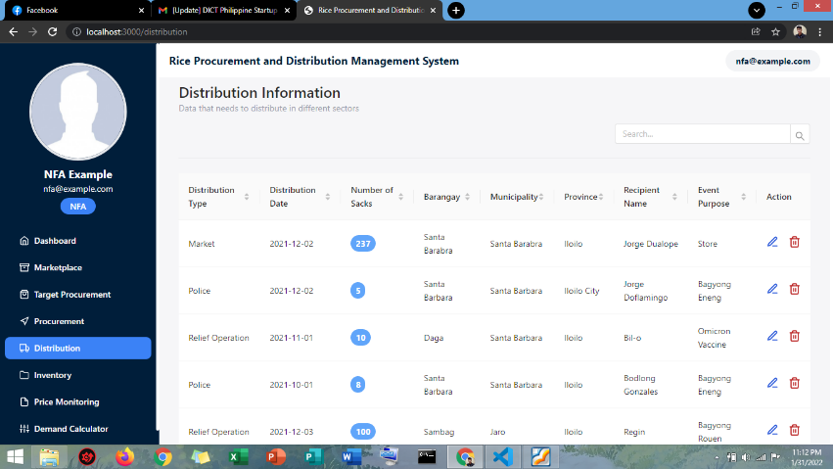

1. **Inventory**, the usage of these pages is to easily identify the **3,6,9 rules of the NFA**. **Three (3) months**, the palay should not be more than 3 months old from the date harvested in buying in the marketplace. **Six (6) Months**, the palay should be milled on or before 6-month-old from the date harvest. **Nine (9) Months**, the rice milled should be distributed on or before 9-months-old from the date of milled. Whenever the NFA procures a palay to the farmer the data is automatically added to the inventory under **procured palay table** and every distribution the inventory is also deducted.

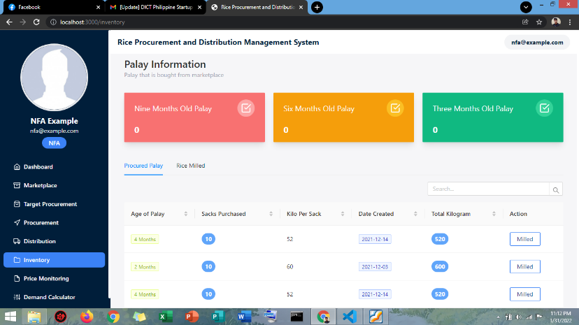

Then the palay that is already milled will added to the **rice milled table**.

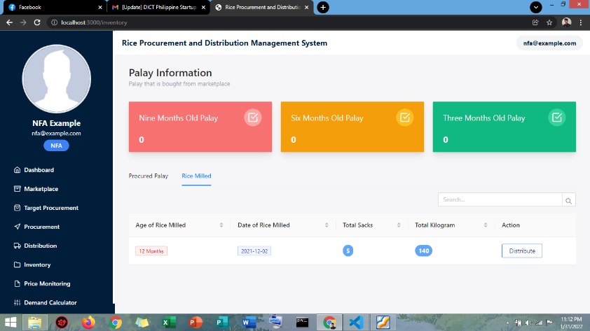

To record distribution: Click **Distribute**, then, **distribution information** will pop up then, input **Distribution date**, **Number of sacks**, **Receipt’s Name**, **Receipt’s type**, **event purpose** and **Barangay** then **Save**.

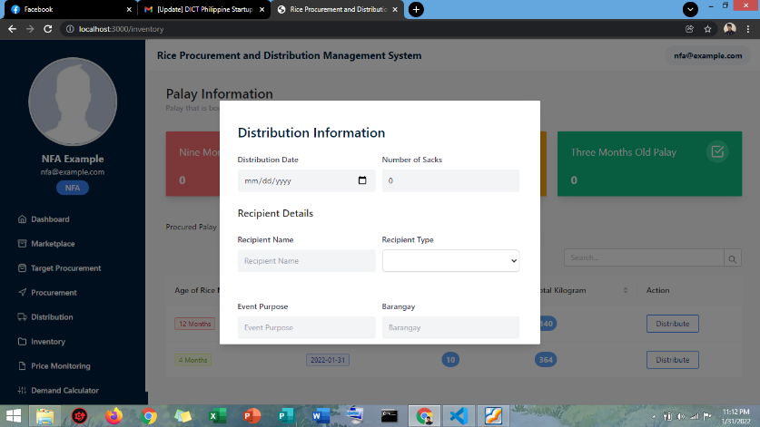

1. **Price Monitoring,** what they can view here is the minimum and maximum price of transaction per variety. The usage of these pages is to determine the average price product per variety in successful transaction.

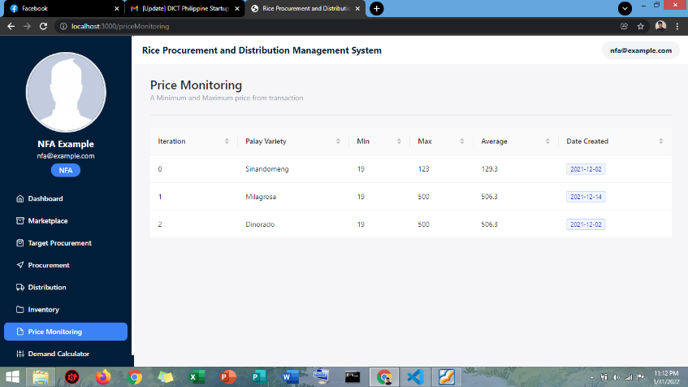

1. **Demand Calculator,** this is the additional feature we made to the NFA. The purpose of this demand calculator is to determine the **total amount of rice** that needs to be distributed in the municipality, for example if there are calamities that needs relief operation.

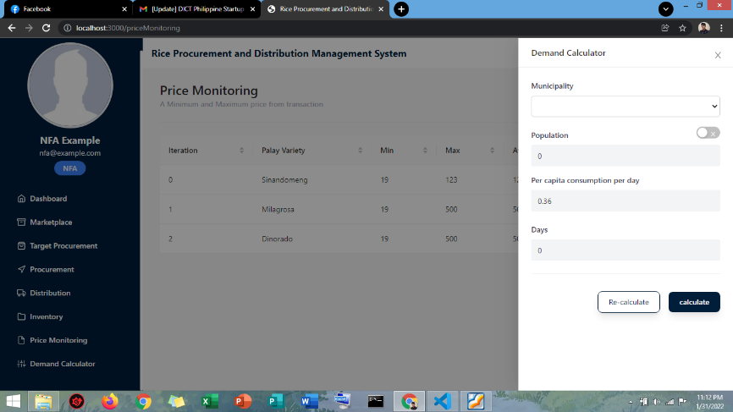

**Troubleshooting for Possible Issues/ Problems**

In case of problem/issues occurrences, try the following.

1. Check the network cables, modem, and routers for connection problem.
2. Restart the web browser and run the system again.
3. Open the **VSCode of the system,** in **terminal**, click **new terminal,** then Enter NPM install, after, **NPM start,** then lastly, NPM start and wait to load the system by the generated local host.
4. If above mention is still not working. restart the PC.
5. Contact the development team for assistance.

**FAQs (Frequently Asked Questions)**

**Q1. What is a rice procurement and distribution management system?**

RPDMS or rice procurement and distribution management system is a web-based system that connect the farmer, traders and NFA for buying and selling rice and palay produce through bidding, whereas this system empower the farmer choose buyers of their produce.

**Q2. RPDMS possible to deployed online?**

Yes, RPDMS will be deployed online. However, the resources of the development team are limited, this management system is deployed in local host for the meantime. If the system is utilized, it can be deployed online so that it can be accessed by the user anywhere if they have the knowledge in using internet connection.

**Q3. Who is the user of the system?**

The users of the system are farmers, traders and NFA.

**Q4. How can we access the system or website?**

The website or the system can be accessed through link provided or generated by running the system in VSCode.

**Q5. How do I know if I have bidding from the traders or NFA? and how do I know if I win the bidding?**

In the transaction page, there’s a bidding history and transaction history. If someone bids for palay, the record will be redirected to the bidding history. You can view the people who bid on the palay, after, you can choose buyer. In farmers user interface, it will appear as a selection whether you accept or reject. In traders and NFA, it will appear won if you are selected or lose if rejected. Then, if you have a successful transaction the record will be redirected to the transaction history.

**Q6. How does RPDMS use my personal details or information for analysis?**

RPDMS uses your personal information details and data especially farmer to make it easier, efficient, reliable for you to find, retrieve, organize, and prioritized your stuffs, clients and collaborate to those who have low income and frequently bid your produce. Also, to avoid duplication of records and scams.

**Q7. How can we benefit from this system?**

This system can benefit all users. For **farmers**, the features that have been implemented are very beneficial to them, especially by empowering them to choose their buyers and sell their produce without losing their capital. Also, we added price monitoring to easily monitor the price in all transactions. For the **trader,** same with the farmer, they ca easily identify and find sellers that are legit, and they can negotiate with the farmers. We also added price monitoring for them to be aware of the prices in every transaction they have. **In NFA**, there are a lot of features we added to the NFA user interface that can surely benefit and help them. One of these is procurement page and distribution page, whereas they can easily add, edit, and delete records and the data that been summarized and gathered will automatically visualize in dashboard which NFA staffs can easily analyze the data. We also added inventory for them to easily track and identify their buffer stock to distribute.

**Q8. Are there any charges if we use this system?**

No, since this system was designed to benefit our primary user (farmer, trader and NFA). The payment or charges depend on the transaction between the buyer and seller.

**Q9. Will any of my personal details or information be recorded and used for other purposes?**

No information will be disseminated or disclosed to the public for any other purposes.

**Q10. How will I know if I’m using farmer or trader or NFA interface?**

Before you sign up you will be asked what username you are creating. After you successfully create your account, every time you log in you will be redirected to what user you create. The other method is on the profile page, it will be indicated of what user you are.

Contact Details of the Development Team

|  |  |  |
| --- | --- | --- |
| **Name** | **Email** | **Contact Number** |
| Karlene Joyce Baes | karlenejoyce.baes@wvsu.edu.ph | 09634643333 |
| Rouen Inawasan | rouen.inawasan@wvsu.edu.ph | 09510851609 |
| Jay Czhelle Soberano | jayczhelle.soberano@wvusu.edu.ph | 09303235919 |